Template for project offers

[*Brought to you by Milient*](https://www.milientsoftware.com/)

We’re thrilled that you have downloaded this template for project offers! Let’s hope you get as good use of it as we have had. Regardless of whether your business is big or small, you will be able to use this template.

The template is based on what a standard project offer contains, and we recommend that you adapt it to your projects.

## This is how you use the offer template:

Use the template as a starting point for your projects. Carefully review and customize each part, so you are sure that the offer will be right for your business.

You can choose whether you want to use the front page with a picture or not.

Through the template, you will find explanatory text in purple that gives advice and suggestions about what you should include in the various parts of the guide. You will of course remove these texts before sending the offer.

## Further tips

On the last page, you will find an appendix where we provide further tips on what you can add to the content. Be sure to read this – here you will find useful information.

Let's start designing your project offer!

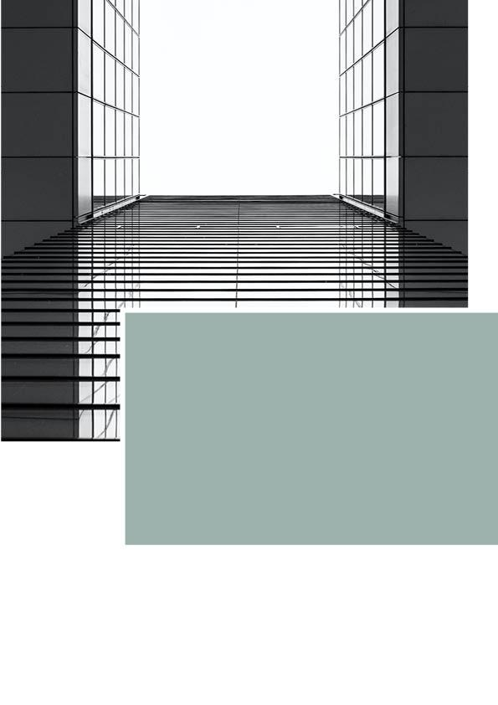

Offer

–

[Name of the project]

Offer: Name of project

To: The Customer’s Company

From: Name Of Your Company

Our reference: John Doe

Date: 01.01.2023

Currency: NOK

Valid until: 31.12.2023

## Offer and project description

Begin with an introductory text. How standardized or personal this text depends on how well you know the customer who will receive the offer. For example, it may say:

We refer to the previous contact and have the pleasure of handing over an offer for the requested services.

Furthermore, you enter information about your business:

**Project Manager**:

Name of your company

Address

Phone number

Email

*Signing this offer is considered accepted assignment confirmation and contract.*

In the following overview, you fill in the phases of the project, with associated activities/tasks. The phases and activities we have set up are only an example for inspiration – replace them with what suits your project.

The overview can be made as detailed as you (or the customer) wish. You can, for example, add columns for the distribution of hours for different roles, where you have different hourly rates for project managers and project members.

Under each new phase heading, you can create a description of what the phase entails, if you think it is useful. Such a description can e.g. be: "Project setup and follow-up. Internal meeting with the division of responsibilities and resource planning."

*Phase and associated activities No. of hours Unit price Discount (%) Sum*

### Project management 55 150

[Optional description]

Project setup 1.00 1 190 100 0

Planning session 14.00 1 120 100 0

Weekly follow-up 85.00 1 180 50 50 150

Project expenses 5 000

### Feasibility study 0 000

[Optional description]

Start-up meeting 0.00 0 000 0 000

Authority requirements 0.00 0 000 0 000

Volume/plan conceptt 0.00 0 000 0 000

Idea sketches 0.00 0 000 0 000

Concept sketch 0.00 0 000 0 000

### Sketch project 0 000

[Optional description]

Plan, section, facade 0.00 0 000 0 000

Drawing 0.00 0 000 0 000

Sketch proposal 0.00 0 000 0 000

Meetings 0.00 0 000 0 000

### Preliminary project 0 000

[Optional description]

Building drawing 1:100 0.00 0 000 0 000

Outdoor plan 1:200 0.00 0 000 0 000

Exit plan 1:500 0.00 0 000 0 000

Situation plan 1:500 0.00 0 000 0 000

Meetings 0.00 0 000 0 000

### Detail project 0 000

[Optional description]

Technical solutions 0.00 0 000 0 000

Drawings 0.00 0 000 0 000

Applications 0.00 0 000 0 000

Material selection 0.00 0 000 0 000  
 Meetings 0.00 0 000 0 000

### Working drawings 0 000

[Optional description]

Drawings 1:50 0.00 0 000 0 000

Form drawings 1:20 0.00 0 000 0 000

Details and sizing 0.00 0 000 0 000

Technical installations 0 000 0 000

Room treatment forms 0.00 0 000 0 000

Meetings 0.00 0 000 0 000

Hours [Total number of hours] [Total sum]

Total [Total sum]

Tal incl. VAT [Total sum incl. VAT]

*All prices are ex. VAT if not stated*

*At the bottom of the offer, enter a closing text. It should contain standard terms, such as which expenses must be covered by customers, and what the price is for excess hours that are not included in the offer. In the following section, we have set up a proposal for standard conditions.*

** The work is carried out in accordance with NS 8401 **

General contract provisions and architectural and engineering standards are applicable at all times.

Our hourly prices are adjusted every turn of the year, also with effect for this agreement.

**Expenses that are not included in the offer:**

? Inspections and meetings that are not specified in the offer are invoiced according to elapsed time.

? Obtain/arrange digital drawing materials.

? Any travel and dietary expenses are invoiced according to actual costs.

? Expenses for larger mailings, copying, printing and expenses in connection with presentations.

? Work with any building notices and review of official requirements.

? Government charges/fees.

? Administration costs of 2% are added.

We emphasize that the estimate is not binding, but is only an assessment of likely hourly consumption. The final fee may be higher or lower than the estimate.

**Disclaimer**

We reserve the right to make changes to the design work. This may lead to a changed cost framework. If this is the case, we will notify you of this. The work is expected to be carried out within normal working hours. All work will be carried out in accordance with stipulated prices and will be invoiced according to the actual time elapsed, with specified time lists attached as the invoice basis.

**Invoicing**:

The work is invoiced continuously per month, in line with the work carried out. The payment deadline is 14 calendar days unless otherwise agreed. If payment is made after the due date, a reminder fee and late payment interest are charged.

We hope the offer is in line with your expectations, and look forward to a good collaboration!

Kind Regards,

Your Company

[www.yourhomepage.com](http://www.hjemmesidendin.no)

Attachement – bonus tips:

Tips for the content of the offer

## Project expenses

Be sure to include project costs among the costs in the offer, so it is clear that the customer pays for this. It is a good idea to mention something about this in a text or show it in other ways in the offer. If not, the customer may come to expect this to be included in the offer and be surprised when the costs are suddenly charged to them without warning. By clarifying this, the customer can see how much will be spent on e.g. travel business.

Here you include information on travel costs, materials, consultants, food, equipment and shipping.

## Discounts

If you carry out activities for which the customer does not have to pay, we recommend highlighting this in the offer. You will then be shown how much time is spent on those activities. A neat way to do it is to enter the activities with a 100% discount.

## Save time on setting up offers and projects - every single time

This offer template is a good starting point for making offers and contains all the necessary information that should be included. But creating and sending offers in this manual way is more cumbersome than it needs to be. You simply spend more time than necessary, and miss out on smart functions that a digital tool gives you.

A digital tool for offer writing gives you some very useful features that you don't get in Excel and Word:

**Electronic acceptance of the offer:** When the customer can accept the offer electronically, you have complete control over the acceptance status, and avoid the risk of an email with the acceptance being lost in the inbox

**Automatic generation of the project straight from the offer:** With a few keystrokes, you can create the project complete with phases and activities. Then you are also assured that the project will be similar to what is promised in the offer.

**Overview of mark-ups:** What you take from mark-ups is visible in the offer to you internally, but not visible to the customer.

[Contact us at Milient](https://www.milientsoftware.com/get-started) if you want to hear more about how the offer tool works. We show you how others in your industry have achieved a better workflow in their projects, and how you can set up your processes.